**Symboles**

**> < ≤** ≥

^

R calculation

For Z distribution

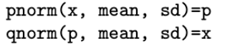

For t distribution :





Finding the mean and sd of a list

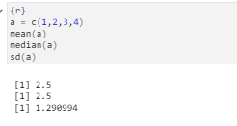

CDF

|  |  |
| --- | --- |
| x | CDF |
| x < 1 | 0 |
| 1 ≤ x < 2 | 0.09 |
| 2 ≤ x < 3 | 0.27 |
| 3≤ x < 4 | 0.48 |
| 4 ≤ x < 5 | 0.6 |
| 5 ≤ x < 6 | 0.67 |
| 6 ≤ x < 7 | 0.72 |
| 7 ≤ x < 8 | 0.75 |
| 8 ≤ x < 9 | 0.79 |
| 9 ≤ x < 10 | 0.89 |
| 10≤ x | 1 |
|  |  |

**Variance**



Mean = 4,74